HOW TO CREATE AUTO SCALLING GROUP

Step1: create a vpc (virtual private cloud)

- Go to vpc console -----> create vpc
STEPS
- Name tag auto-generation : add name ex → project-demo

- Number of Availability Zones : 3

- Number of public subnets :3

- Number of private subnets : 0

- Nat gateway : None

- Vpc endpoints : None

----------------------------------------------click create vpc -------------------------------------------------------
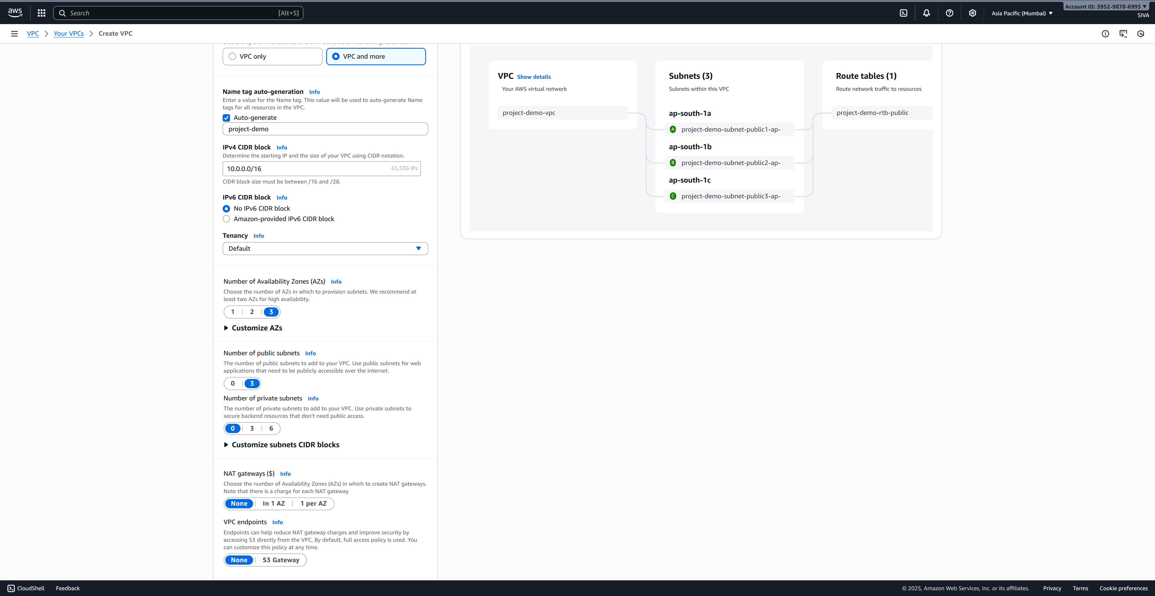

Step 2: set up the security groups
- Go to security groups -------> first choose the vpcid then -----> set the inbounded and outbounded rules and save it
INBOUNDED RULES : image
INBOUNDED RULES OUT BOUNDED RULES
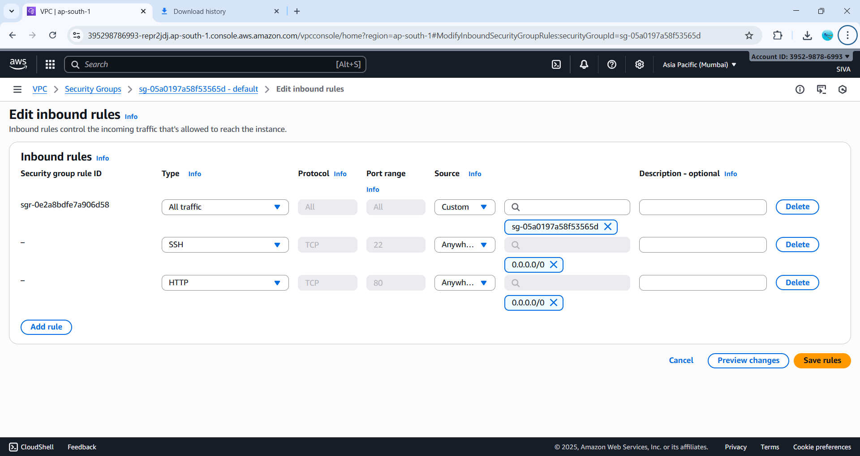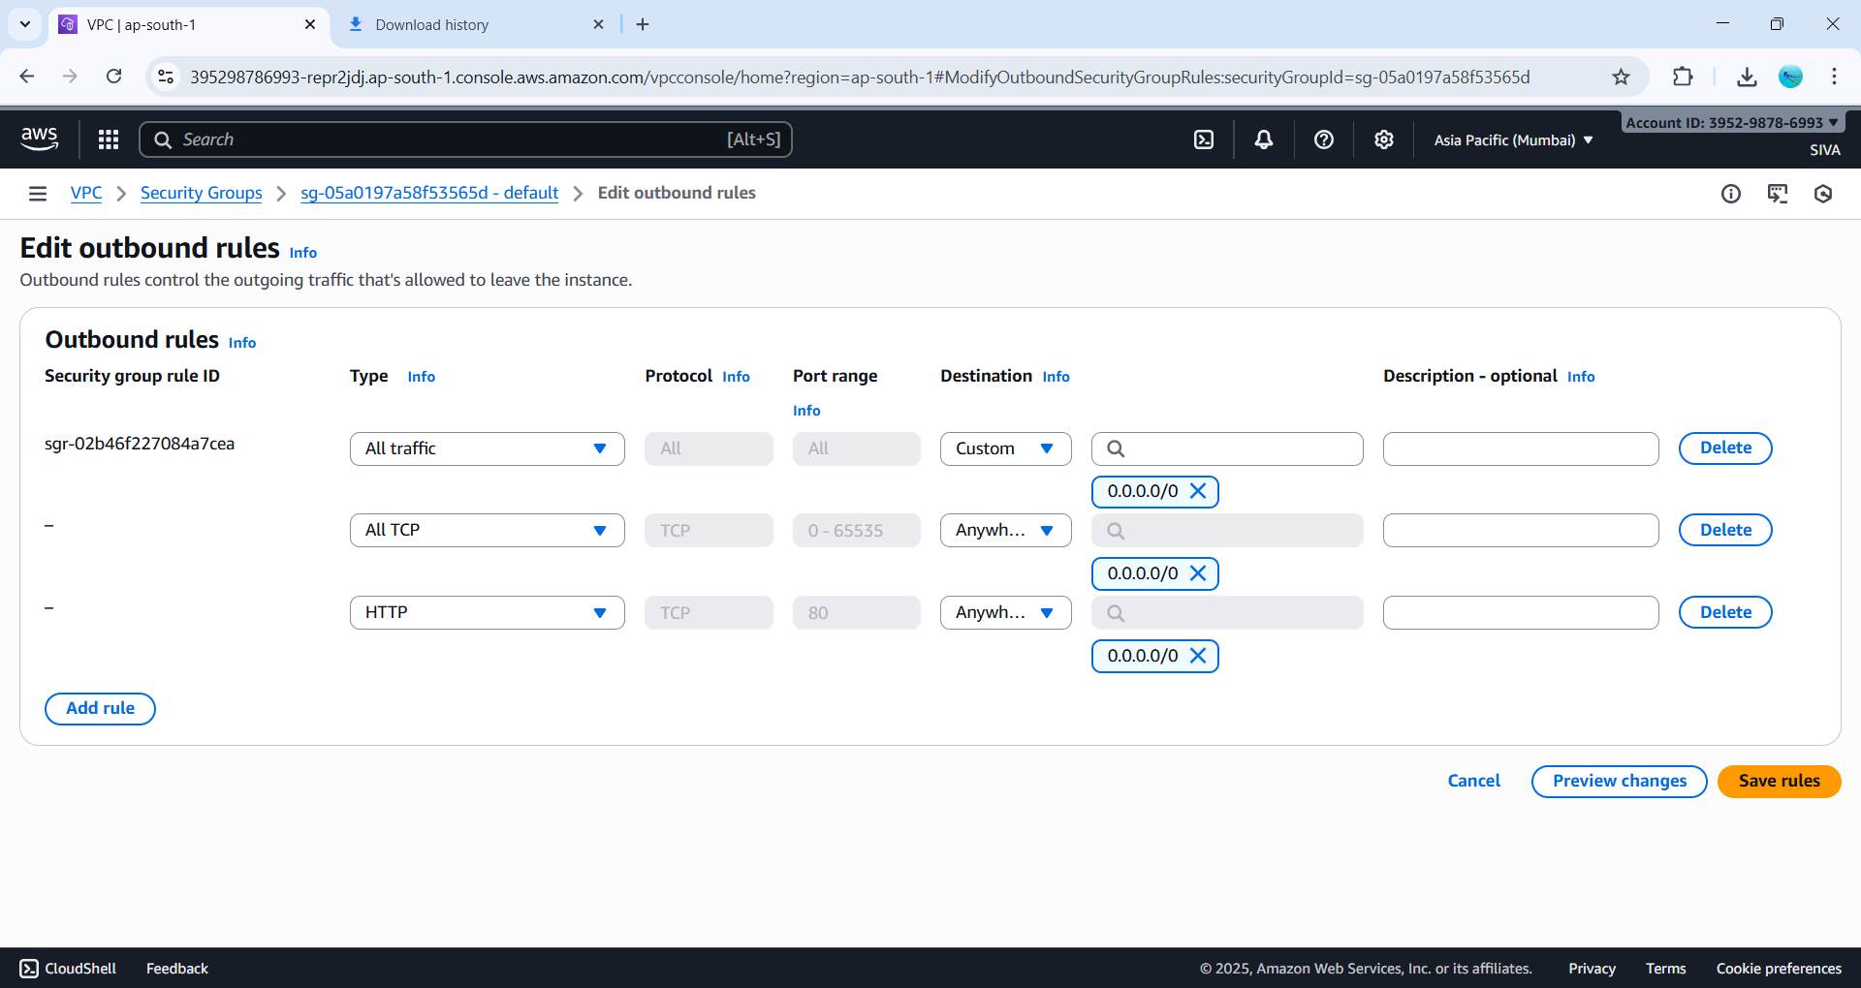
step3: create an one instance and attach image and template

- Create a instance

- Go to EC2 ----> launch instance

- Give Name ----> EX:siva

- Choose Amazon Machine Image (AMI ) :amazon linux 2023 kernal-6.12AMI

- Instance type :type3.micro

- Select you keypair : linuxxx

- Select your vpc : project-demo

- Auto-assign public IP : enable

- Attach the security group : default

- advanced detail ----->user data , paste

Now we create one instance and go to chrome browser then paste ip address

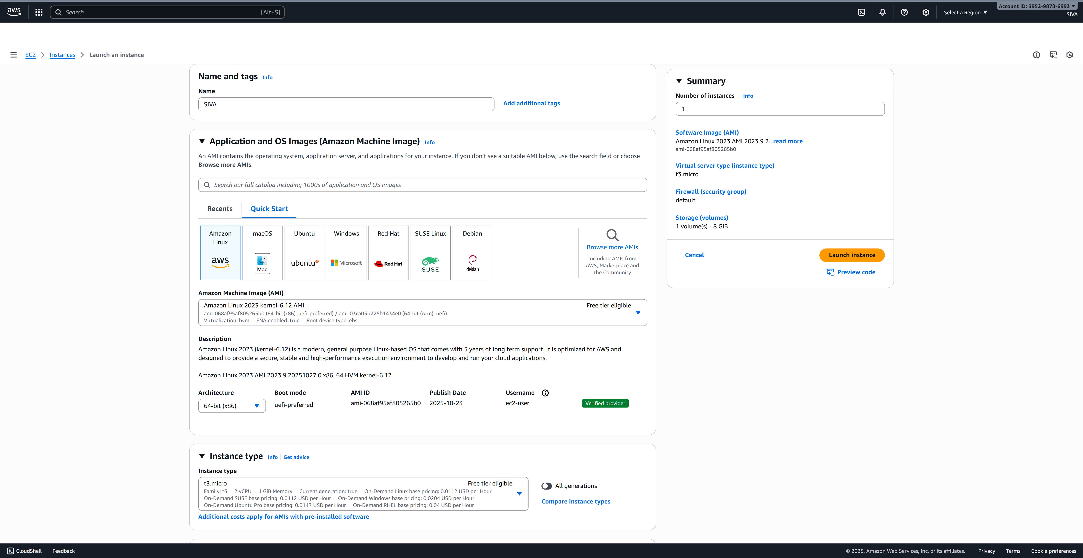
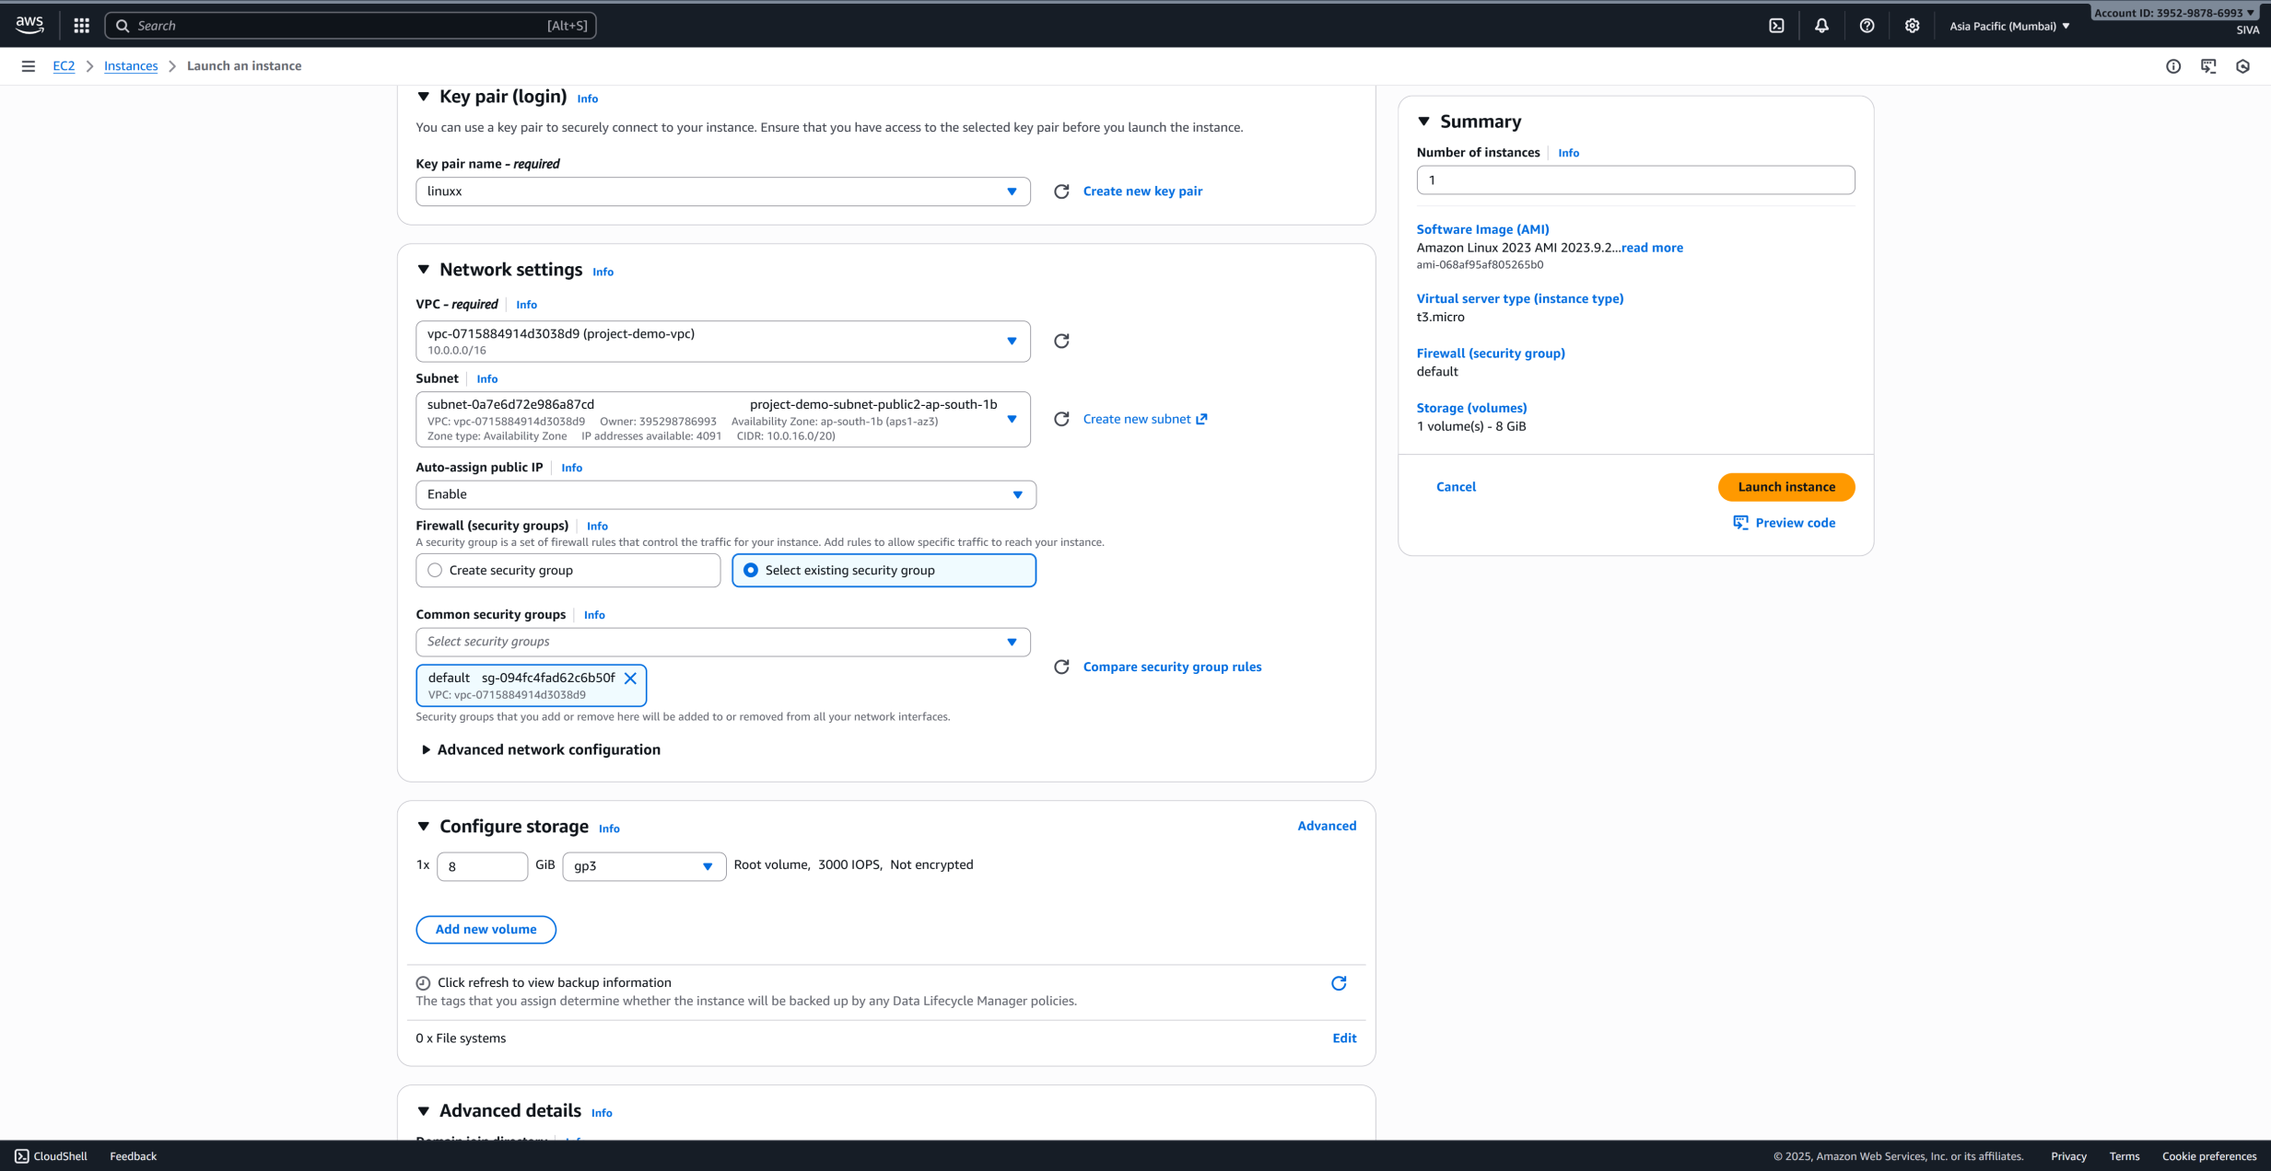
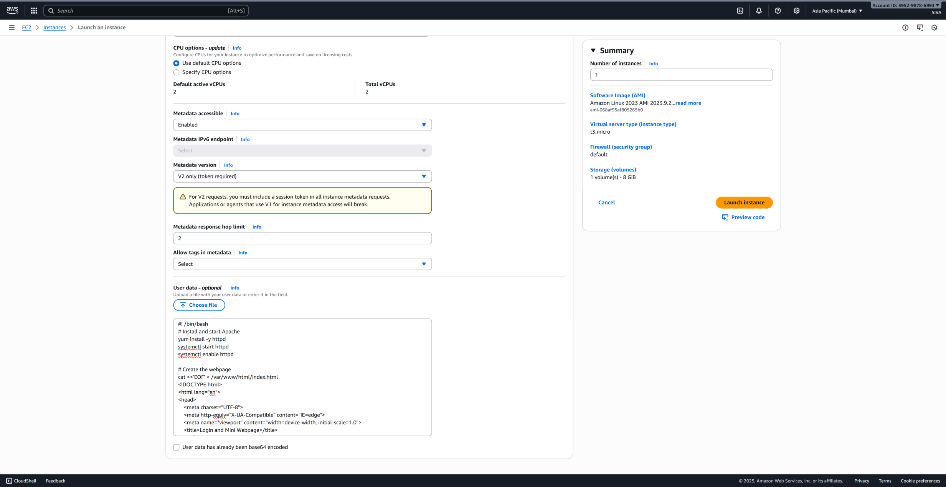
Step 4: create an AMI from the instance

Go to EC2 instance ----> actions ----> image ---->create image
- Image name : siva image

- Image description : backup purpose

- Click : create image
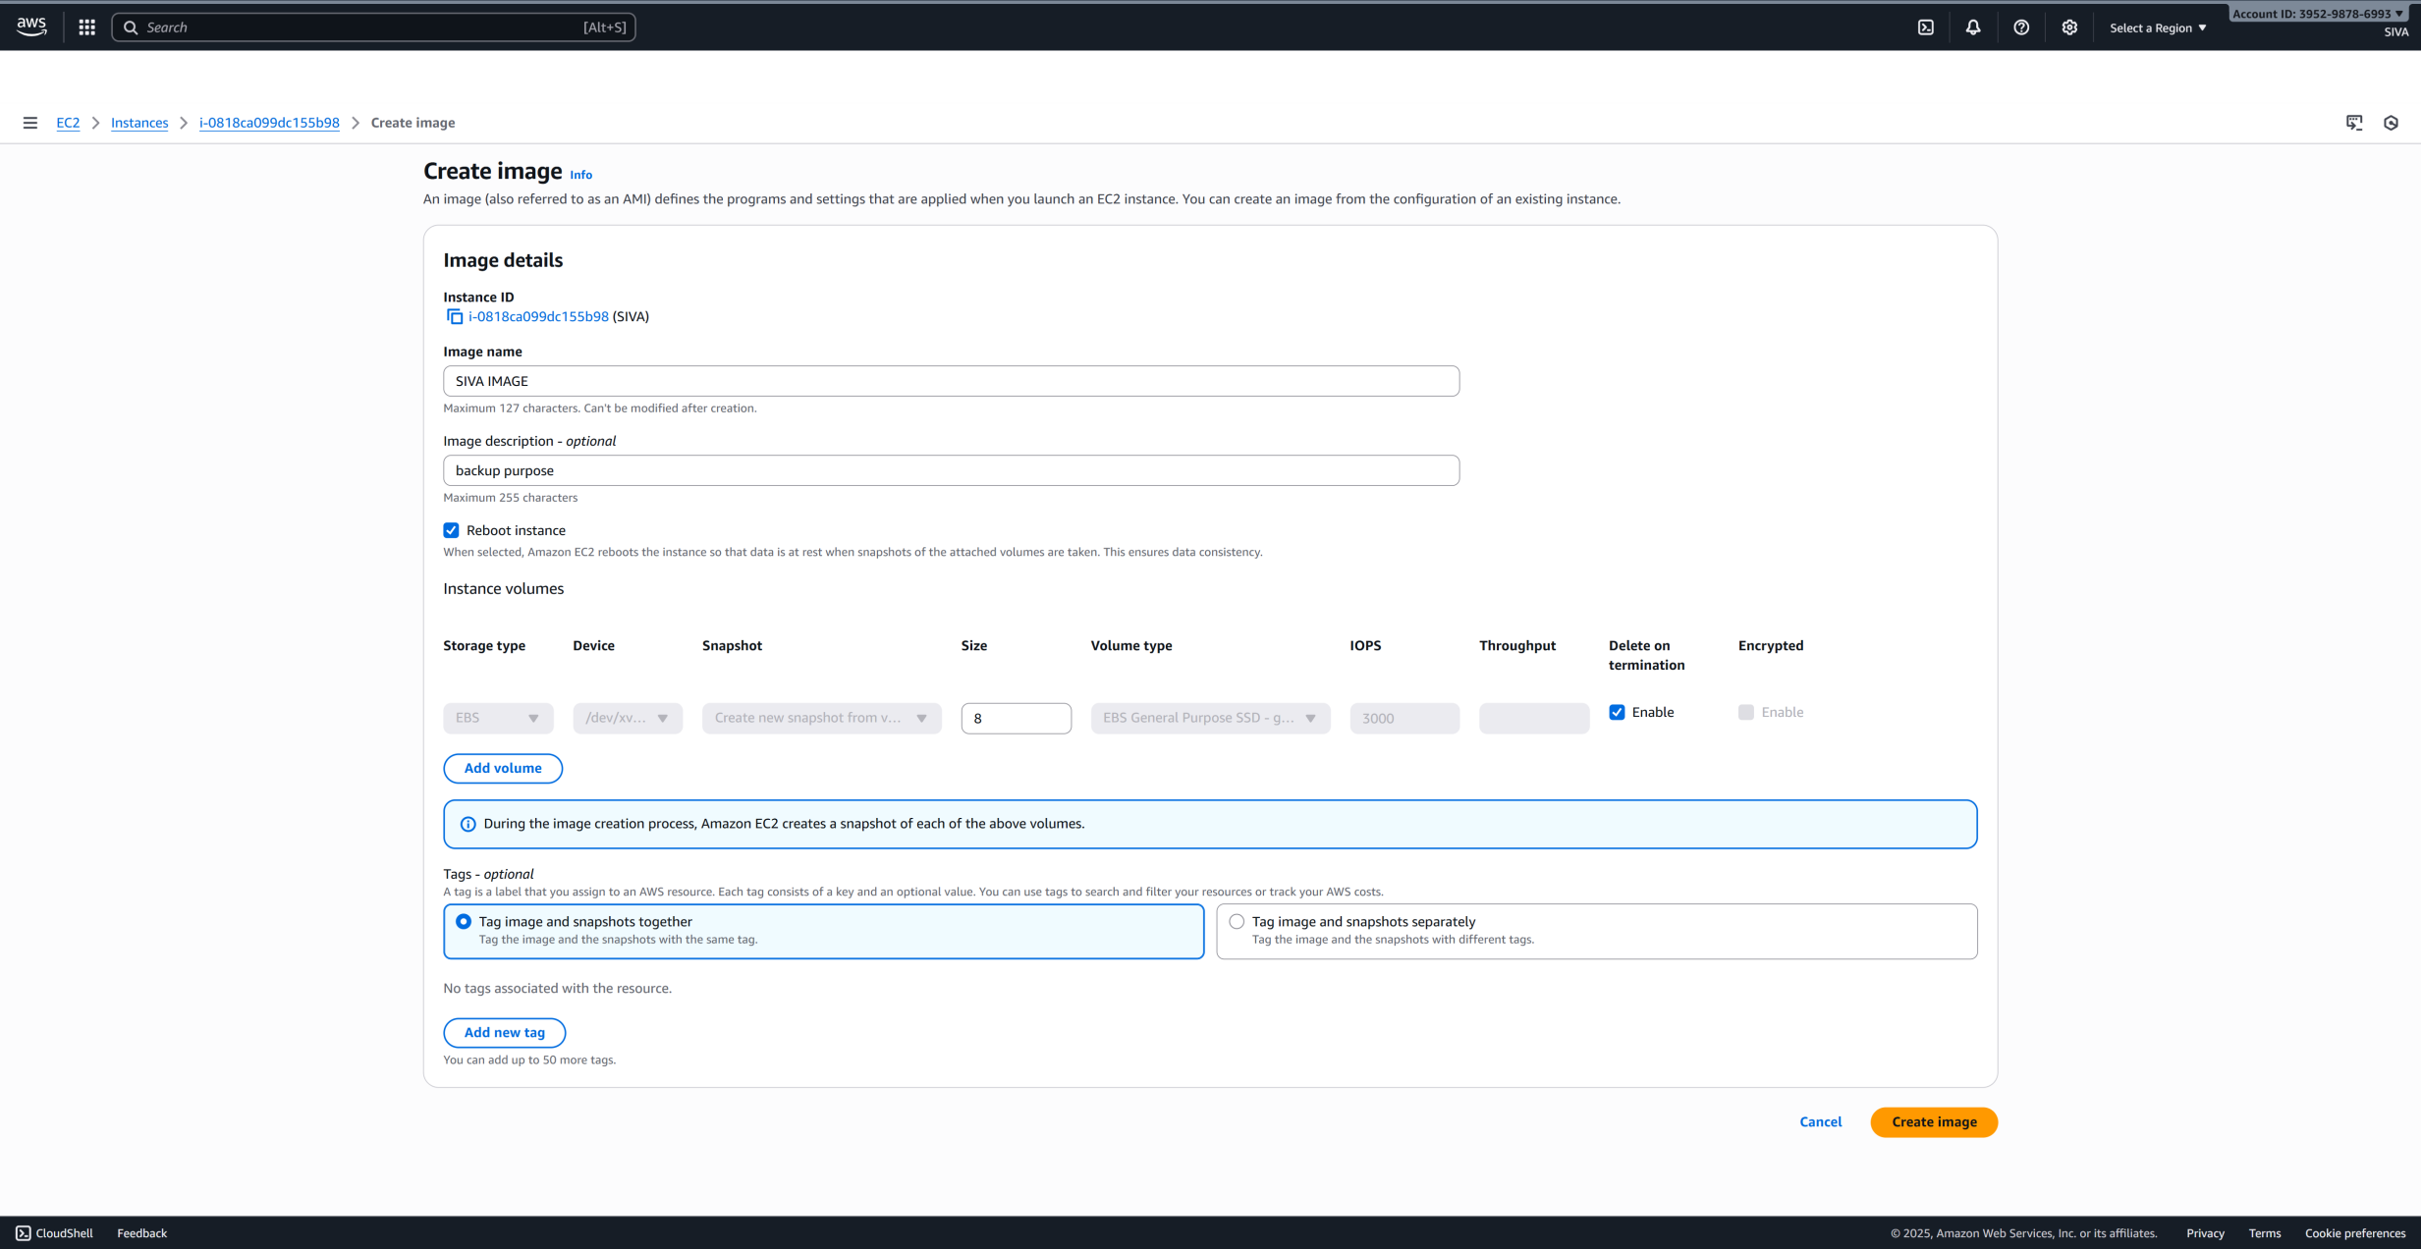
Step 5: create a launch template
Go to EC2 ----> launch template ---> create launch template

- Launch template name : ex : siva template
- Template version description : this my template
- Choose your AMI :siva image
- Select Instance type :t3micro
- Select your Key pair name : linuxx
- Select Network settings

Click template create
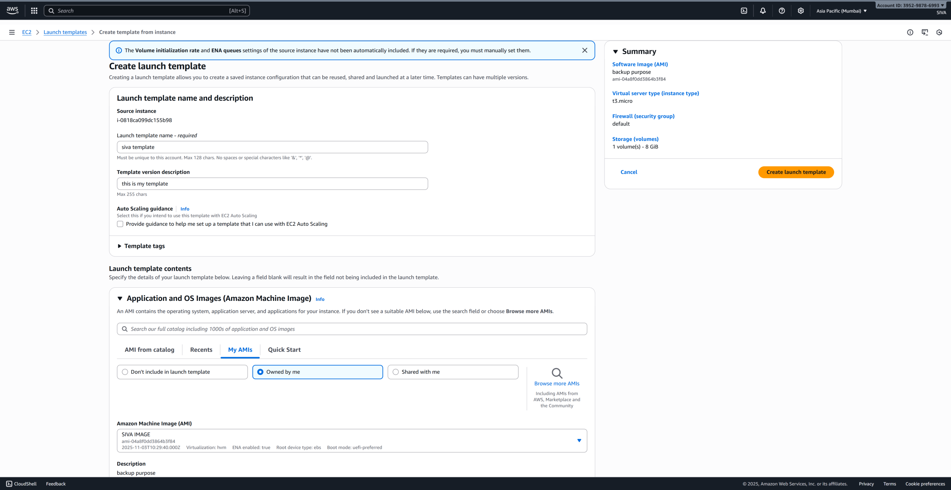
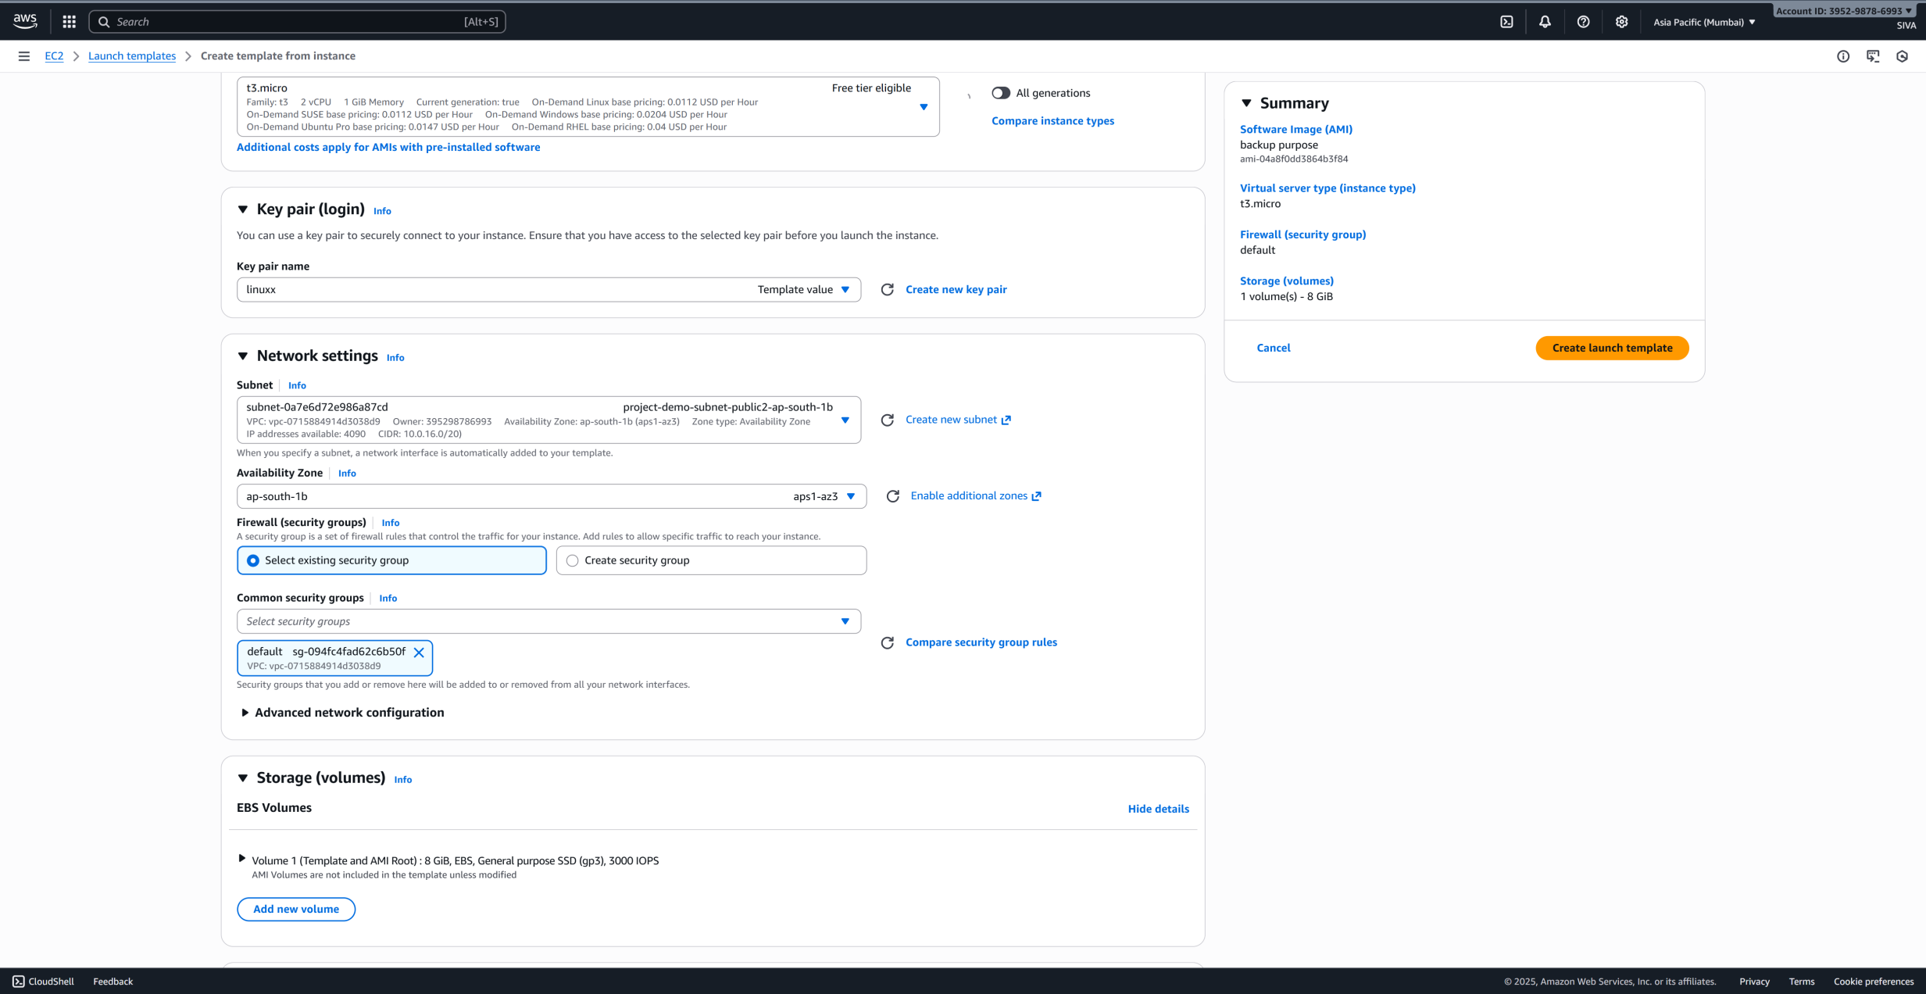
Step 6 : create a load balancer :

Steps
Go to EC2 ----> load balancer -----> create a load balancer

- Create a classic load balancer ---> load balancer name ---> CLB

- Edit network mapping
Select your vpc
Availability zones and subnets : ap-south-1a (aps1-az1) ap-south-1b (aps1-az3) , ap-south-1c (aps1-az2)
Select security groups
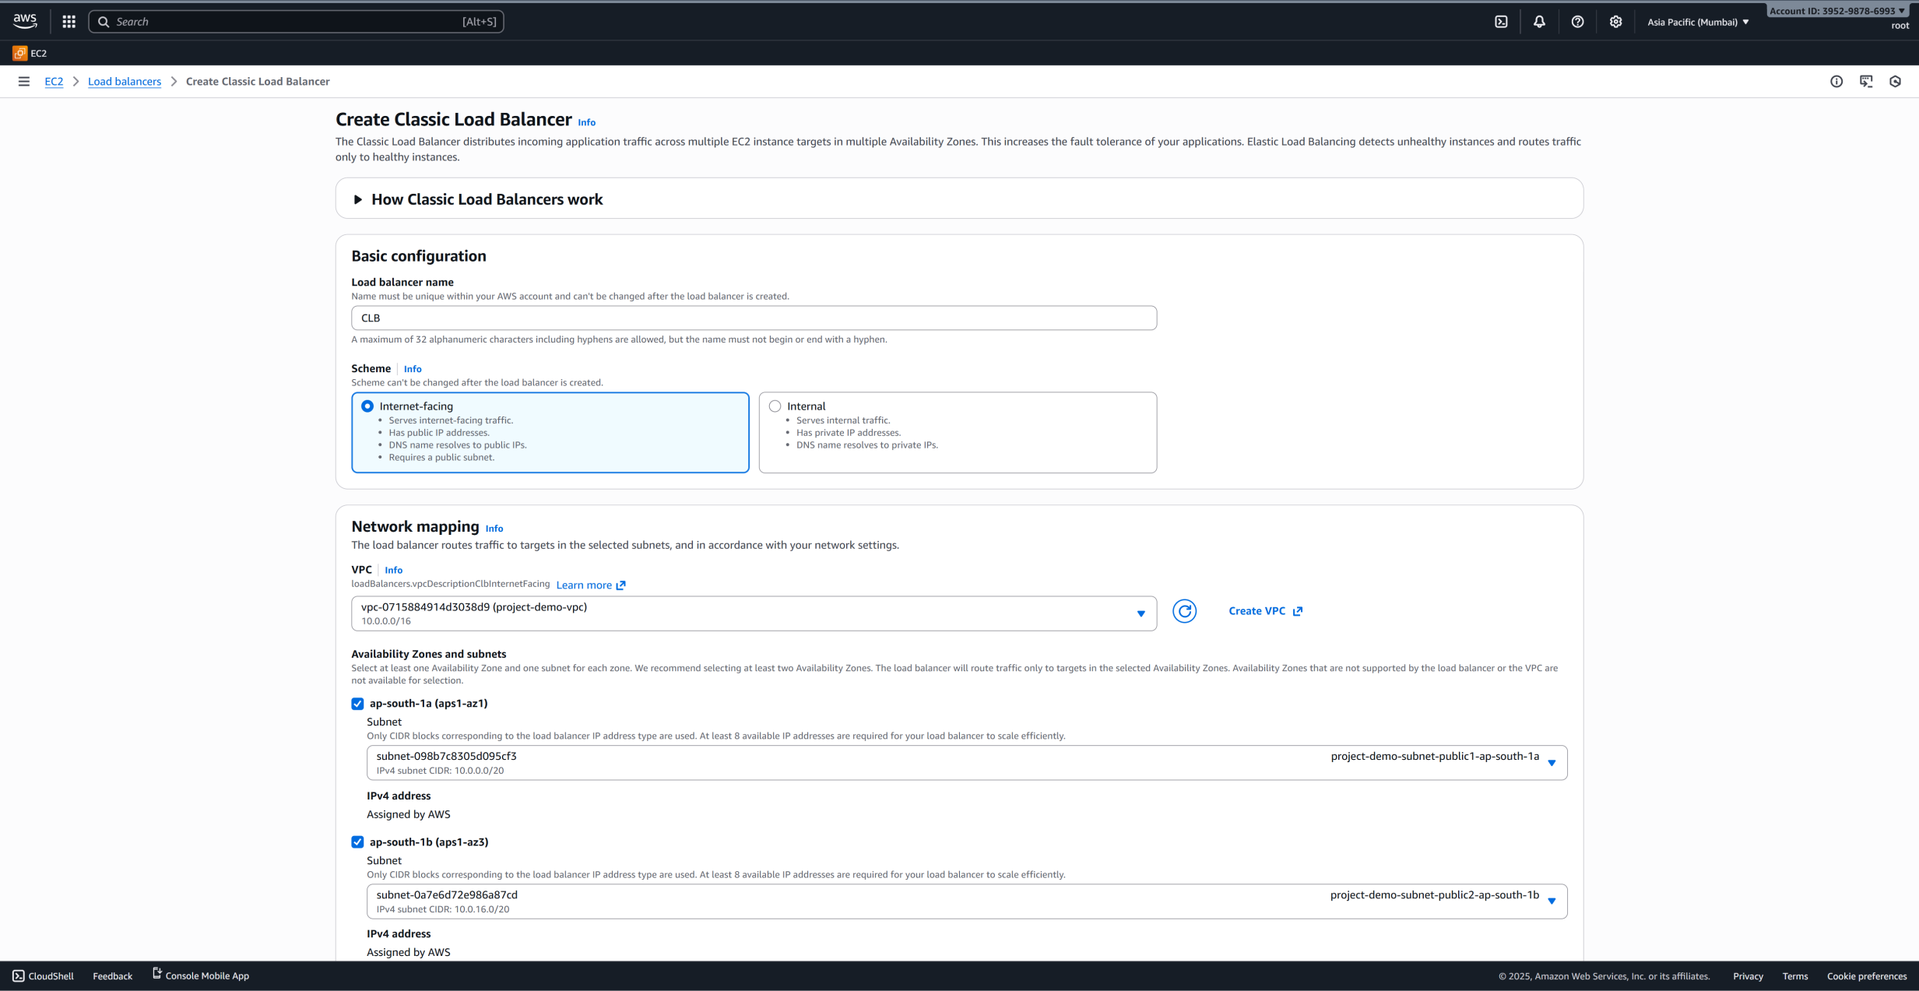
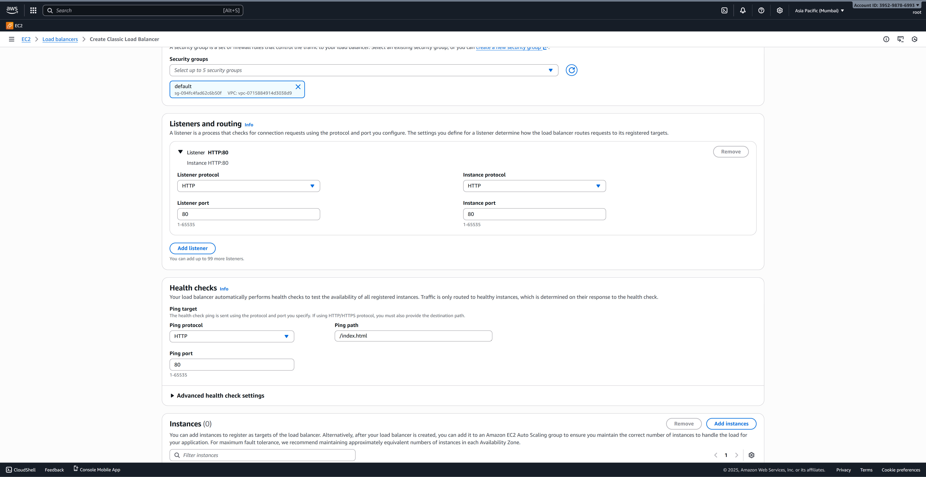

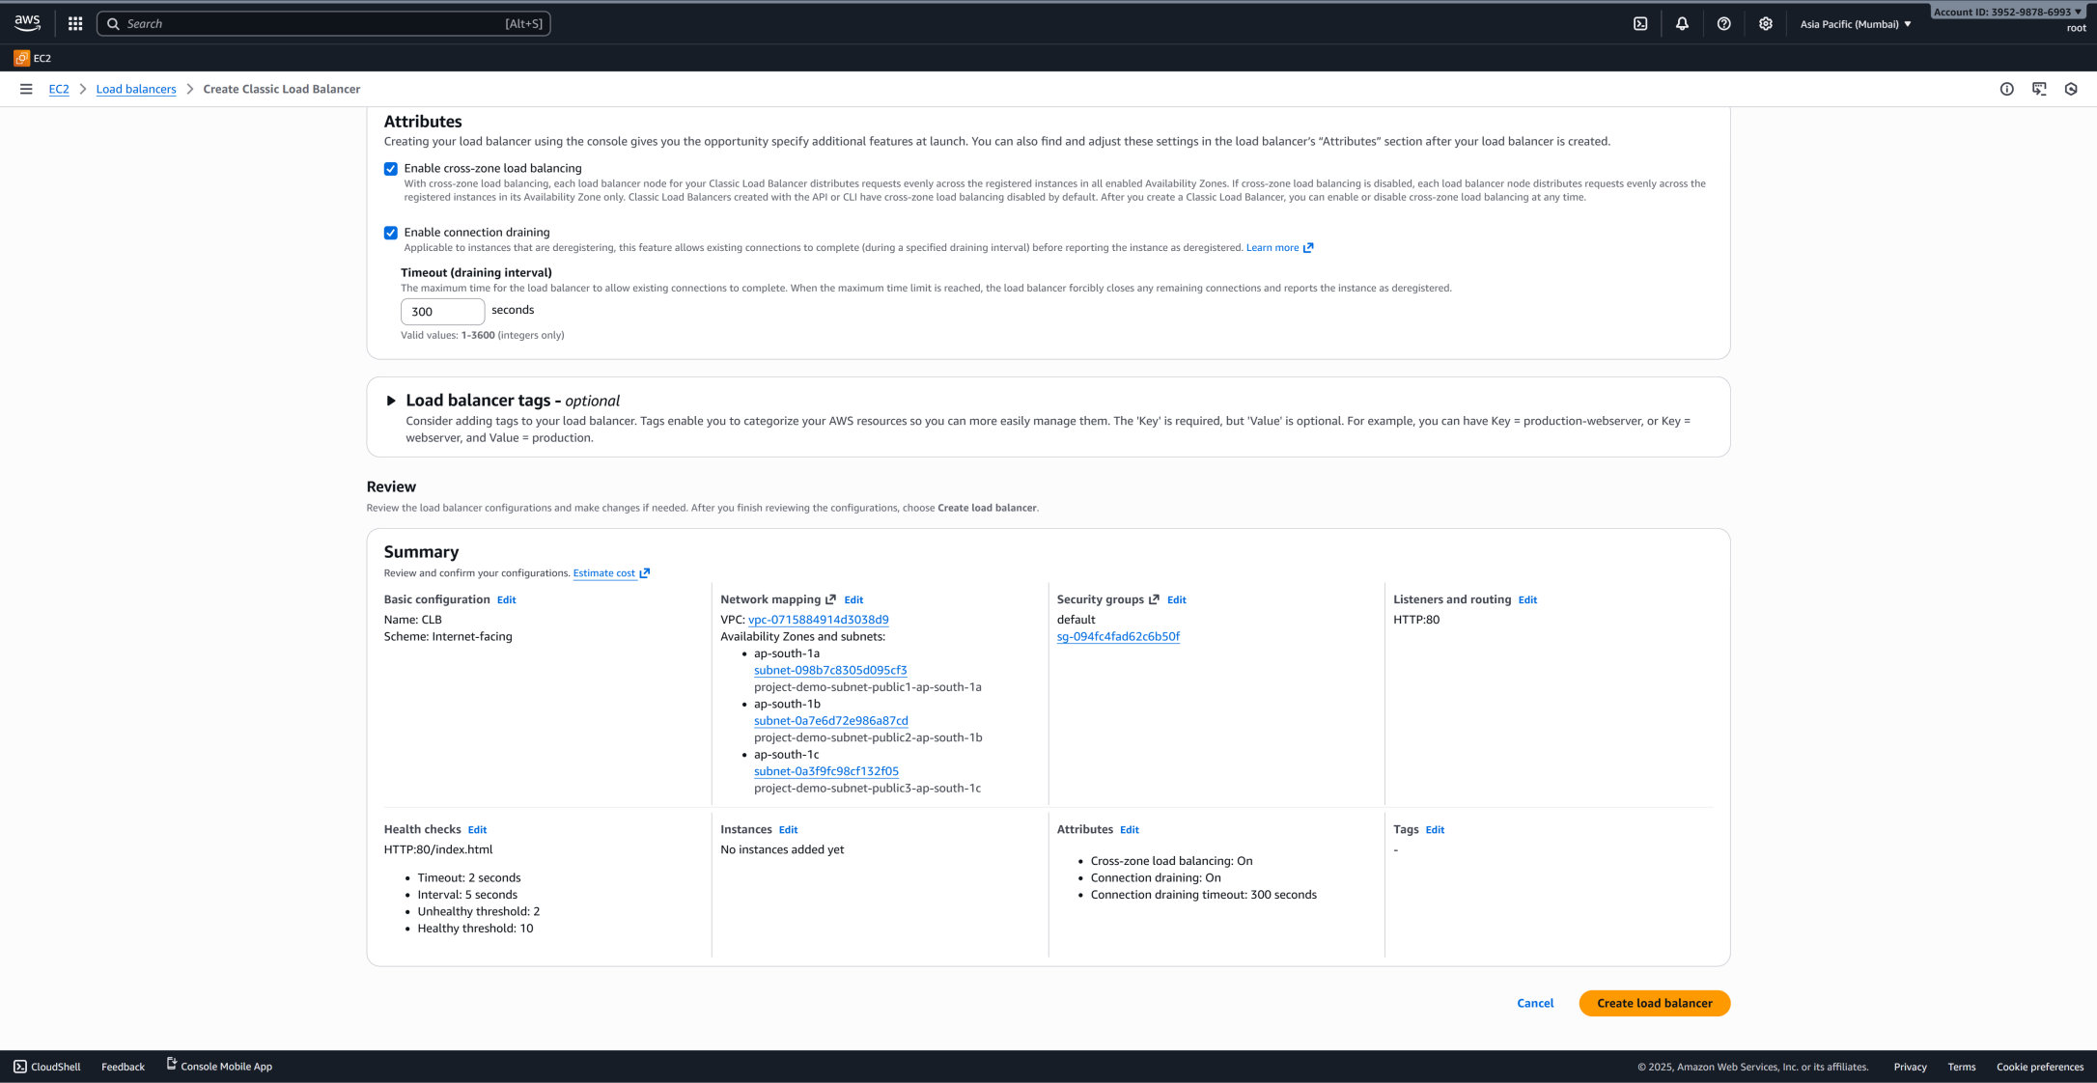
After creater a classic load balancer check DNS name :CLB-923948916.ap-south-1.elb.amazonaws.com

Step 7 : create an auto scalling group

Go to EC2 ---> auto scalling groups ---> create an auto scalling group
- Auto scalling groups name : alg
- Select your template : siva-template
NEXT PAGE

- Network : select your vpc
- Select availability zones : 3 1a.1b.1c
NEXT PAGE
- Attach to an existing load balancer ---->choose from classic load balancer -----> select your classic load balancer
NEXT PAGE
- Desired capacity :3
- Scaling limits---> min desired capacity : 3---->max desired capacity--->5
- Select monitoring : enable (it is optional)
- Simple notification service (sns) ---> create topic -->name : siva-->
Create subscription ---> select protocol---> Email -->end point enter email address
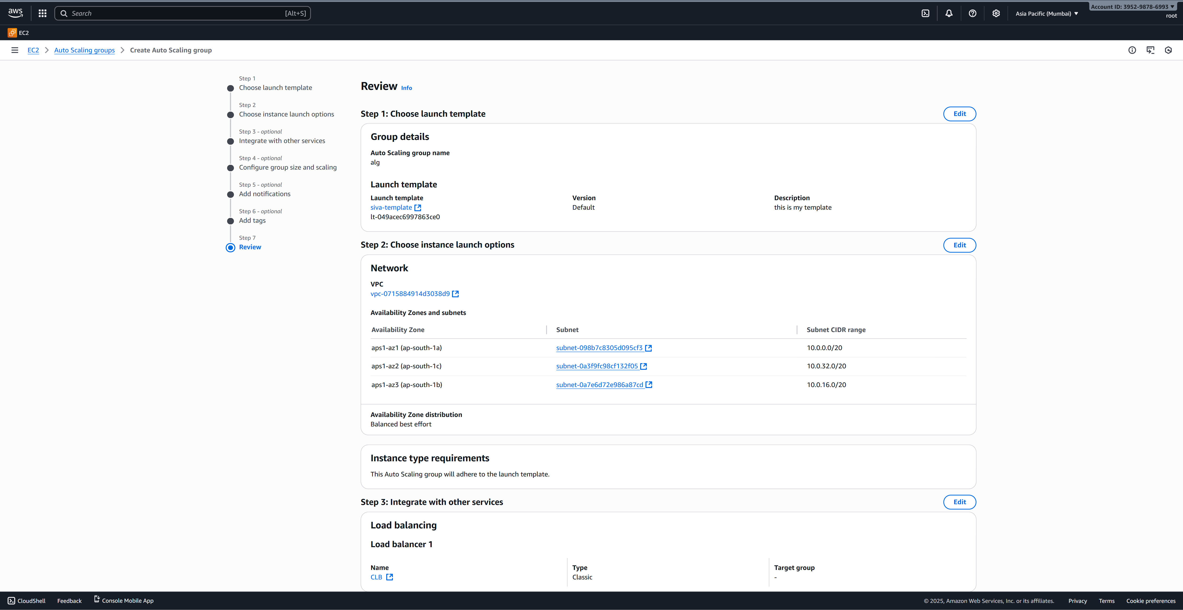
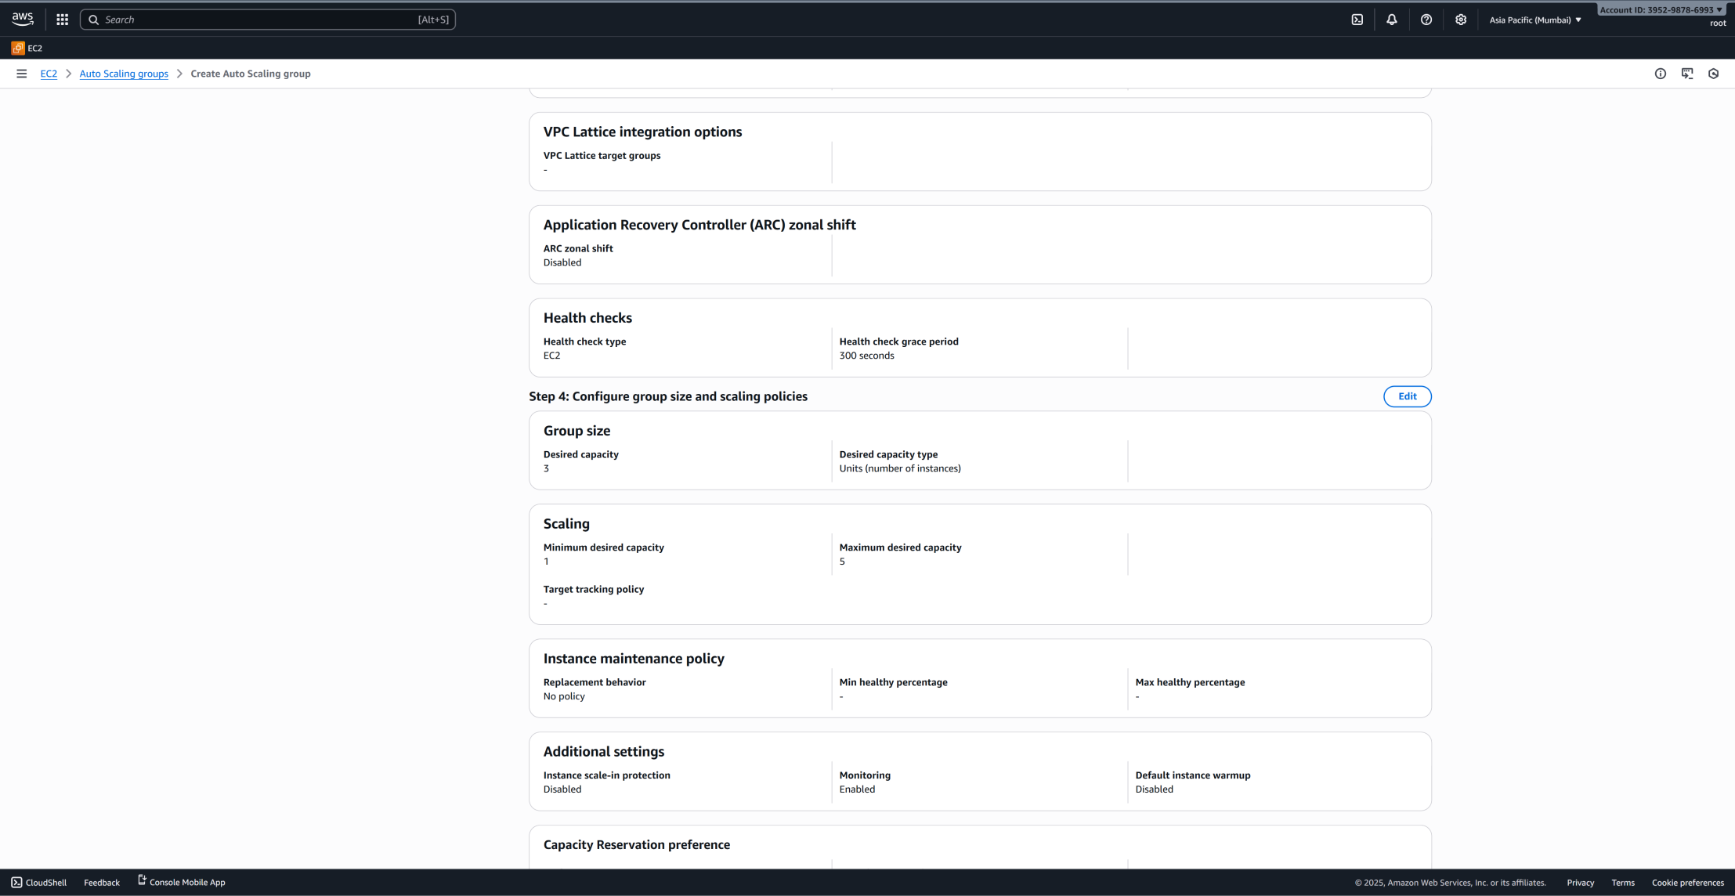
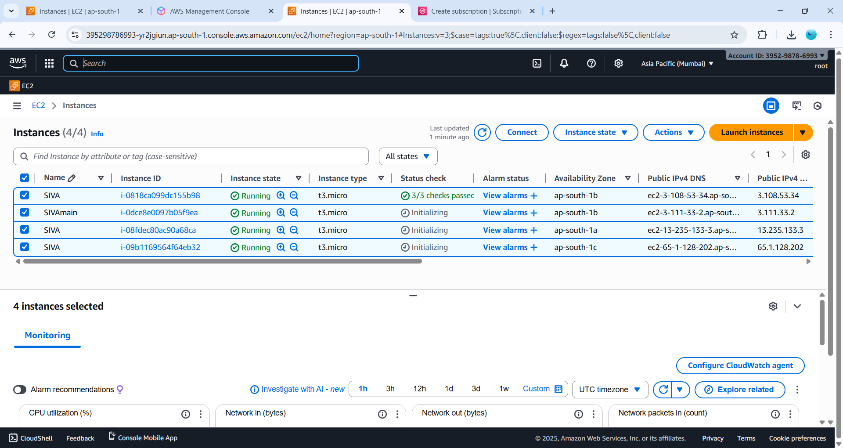
Step 8 create an another application load balancer

First we create an target group

Target group---> t.g name : ssa --->select your vpc ---> health checks path: index.html

Go to load balancer ----> create application load balancer

- Create application load balance name ---> select your vpc

- Select availability zones

- Attach target group
- Create application load balancer

- Attach to auto scalling groups

